**Power BI – Day 1**

**Omshree R Hiremath**

**Employee Code: 655127**

Excel plugins:

1. Power Query- Used to connect and transform data. It is a data transformation and data preparation tool included with Microsoft Excel and Power BI
2. Power Pivot
3. Power View - Different visualizations
4. Power Map

3 Tabs in PowerBI

1. Report tab
2. Data tab
3. Model tab: Define relationships

PowerBI Query editor uses the m language

Dax(Data Analysis Expressions) functions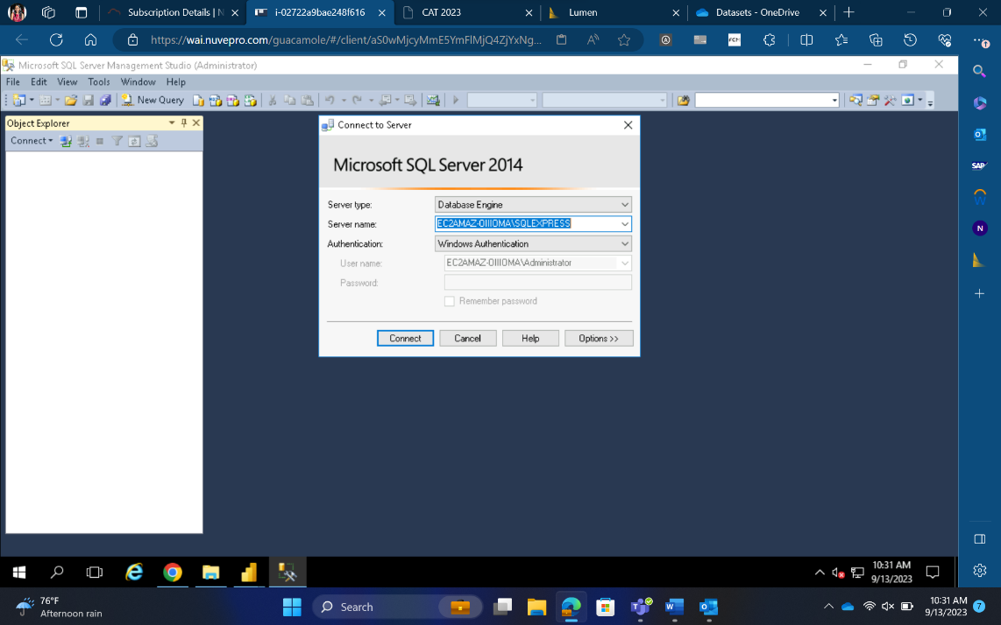

Sources of Data:

1. Excel sheet
2. SQL Service
3. CSV/Text

Data Connectivity Mode in PBI:

1. Import Mode: Store the data in PowerBI
2. Direct Query: Read the data from db every time and then display. Useful for confidential data

Calculated Column and measures

Importing Data from various sources:

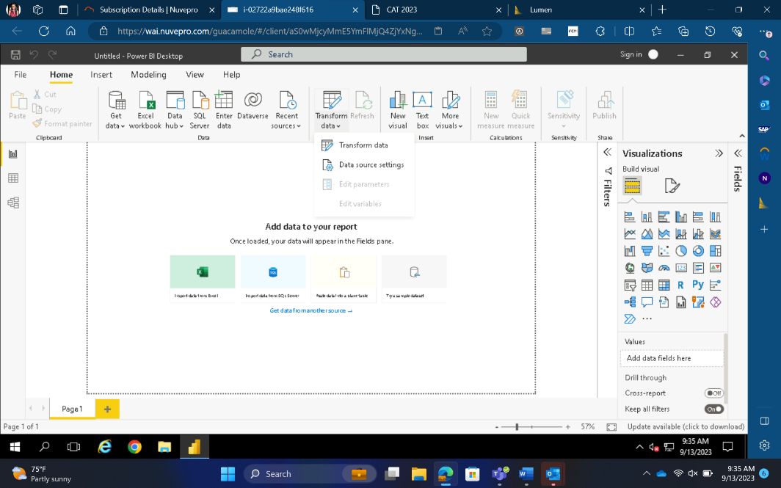

Modelling view of the imported tables

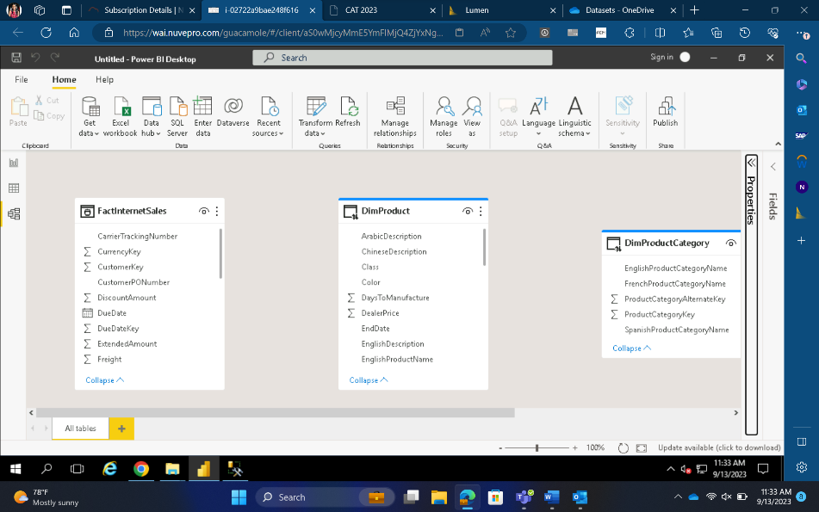

Creating relationships between tables based on foreign key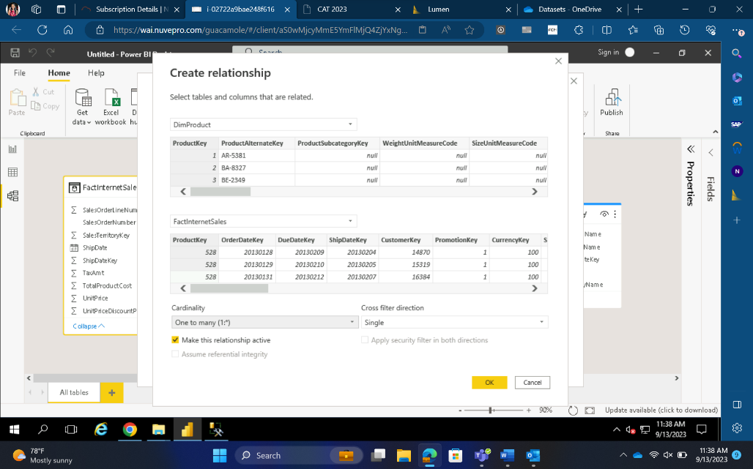

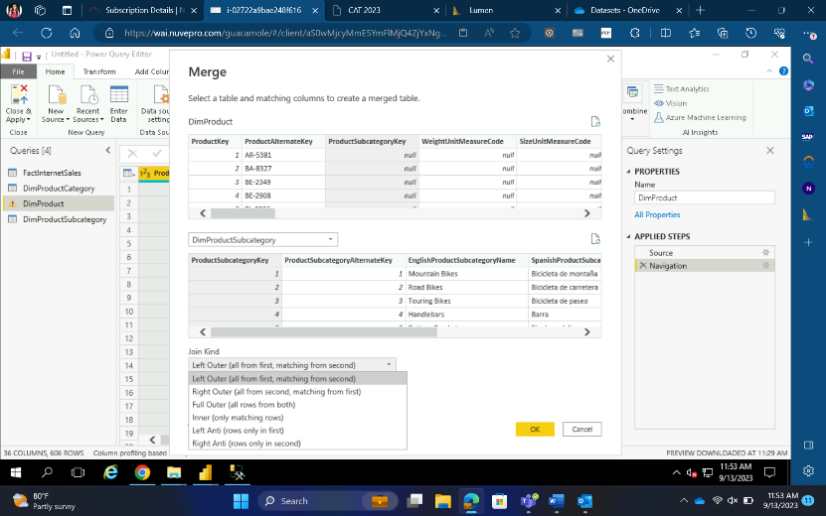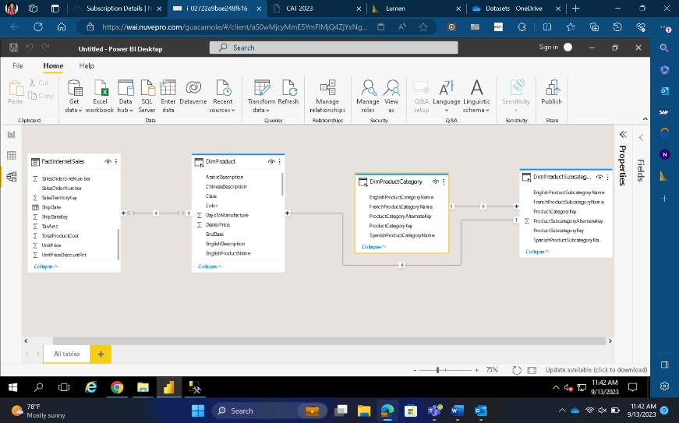

Performing Joins on the different tables as needed

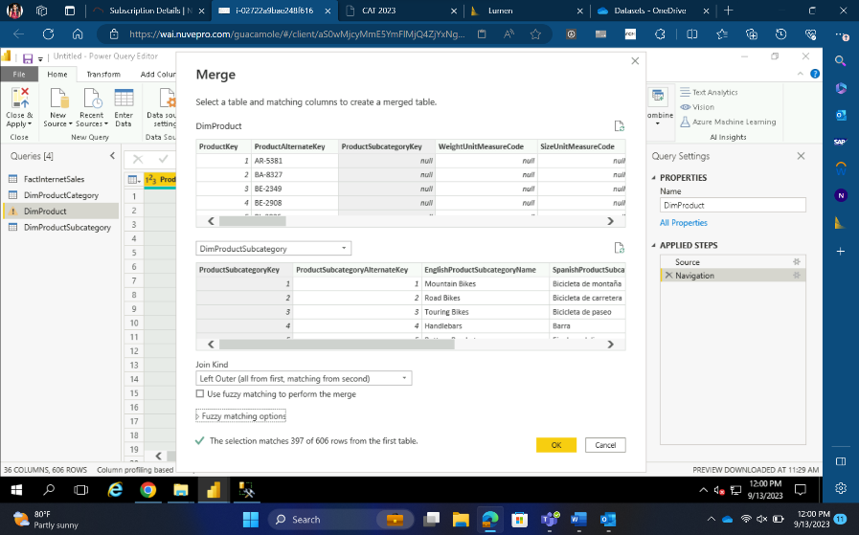

Plotting bar graph

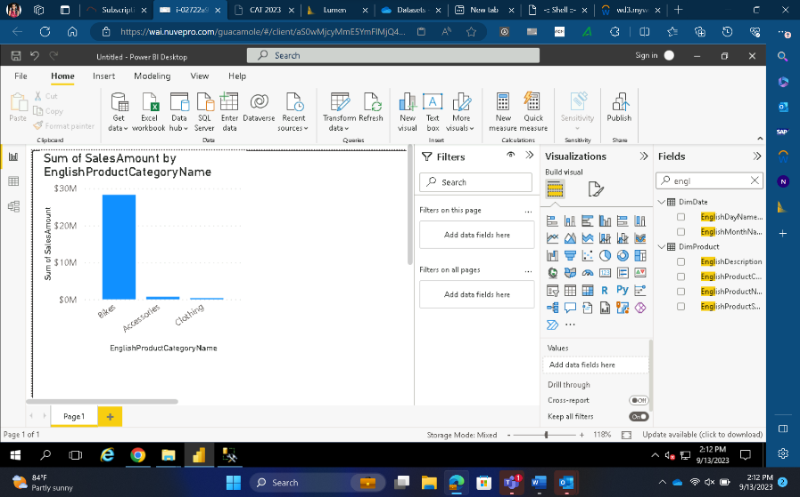

Creating tables for analysis

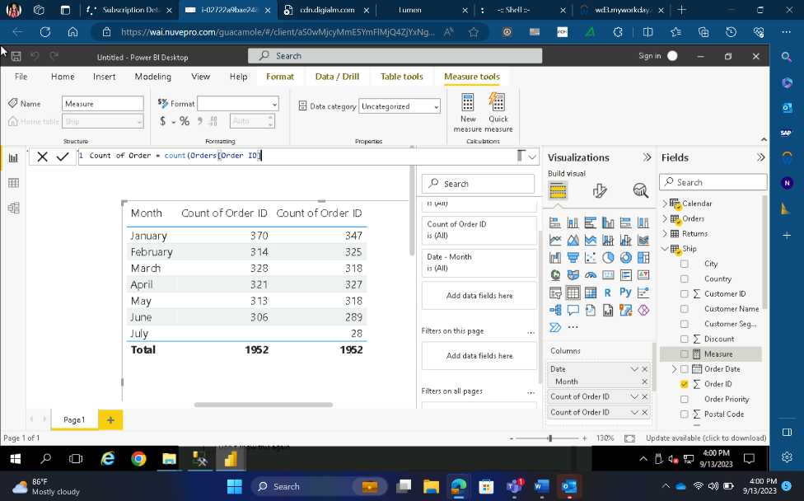

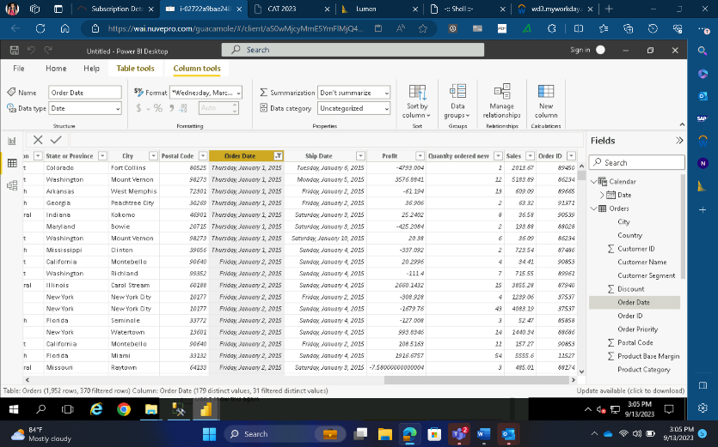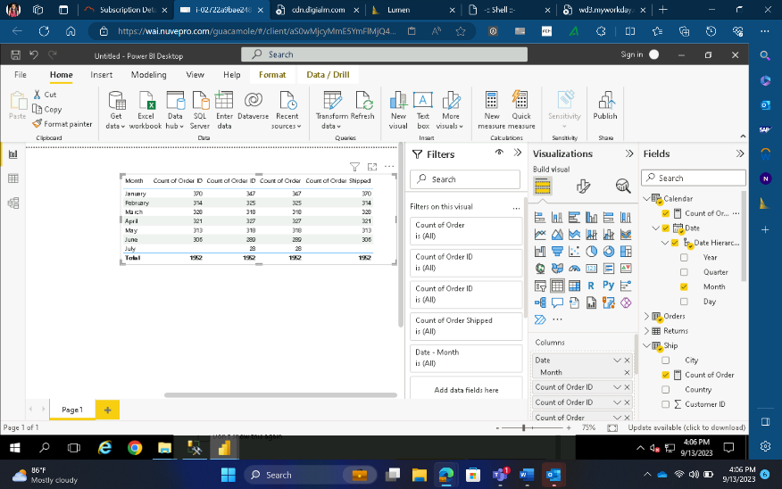

Creating Sliders

